SUBJECT : LAB JAVA FULL STACK
BRANCH: AIDS B BATCH B3
GROUP MEMBERS: ROLLNO:
1 GAURAV CHALAKH 140
2 JAYDIP RATHOD 143
3 MAYUR DIGHORE 147
4 RISHAV SINGH 158

PROJECT TITLE
WEATHER REPORT APPLICATION
1. Introduction
Weather forecasting plays a crucial role in daily life, helping individuals and organizations make informed decisions. Traditional weather information sources may not provide personalized or real-time updates efficiently.
This project presents the design and implementation of a Weather Report Application developed using Java for backend processing and HTML, CSS, and JavaScript for the frontend interface. The system fetches real-time weather data using an API and displays it in a user-friendly format. An AI chatbot is also integrated to assist users with weather-related queries.

2. Objectives
The primary objectives of the project are:
• To develop a web-based weather information system
• To fetch and display real-time weather data
• To provide location-based weather reports
• To enable user-friendly interaction
• To integrate a simple AI chatbot for assistance

3. System Overview
The application follows a client-server architecture, where:
• The frontend (HTML, CSS, JavaScript) handles user interaction
• The backend (Java) processes API calls and logic
• External Weather API provides real-time data
Technology Stack
• Backend: Java (Servlets / JSP / Spring Boot)
• Frontend: HTML, CSS, JavaScript
• API: OpenWeatherMap API (or similar)
• AI Module: Rule-based chatbot or API-based chatbot

4. Functional Modules
4.1 User Input Module
This module allows users to enter location details.
Features:
• City search
• Auto-suggestions (optional)
• Input validation
Working:
• User enters city name
• Backend processes request
• API fetches weather data

4.2 Weather Data Module
Core module responsible for displaying weather information.
Features:
• Temperature display
• Humidity levels
• Wind speed
• Weather conditions (Cloudy, Sunny, Rainy)
Data Attributes:
• Temperature
• Humidity
• Pressure
• Wind Speed
• Weather Description

4.3 Forecast Module
Displays future weather predictions.
Features:
• 5-day forecast
• Hourly updates (optional)
Logic:
• Data fetched from API
• Parsed and displayed in UI cards

4.4 Weather Condition Indicators
Visual representation of weather conditions.
Indicators:
• Sunny → Yellow
• Rainy → Blue
• Cloudy → Gray
• Storm → Red

4.5 Real-Time Update System
Provides updated weather data.
Logic:
• Refresh data periodically
• Fetch latest data from API

4.6 AI Chatbot Module
A simple AI chatbot is integrated into the system.
Functions:
• Answer weather-related queries
• Provide temperature updates
• Suggest precautions
Example Behavior:
• User: "Weather in Nagpur"
• Chatbot: Displays current weather
• User: "Will it rain today?"
• Chatbot: Provides prediction

5. System Design
5.1 Architecture Diagram (Conceptual)
Frontend → Java Backend → Weather API → AI Chatbot

5.2 Database Design (Optional if used)
Users Table:
• user_id (Primary Key)
• username
• password
Search History Table:
• id (Primary Key)
• city
• timestamp

6. Algorithms and Logic
Weather Fetch Algorithm
- Take city input
- Send API request
- Receive JSON response
- Parse data
- Display results

Temperature Conversion Algorithm
- Get temperature in Kelvin
- Convert to Celsius:
C = K - 273.15

Forecast Processing Algorithm
• Extract multiple entries from API
• Group by date
• Display summary

7. User Interface Design
Frontend Technologies:
• HTML → Structure
• CSS → Styling
• JavaScript → Dynamic interaction
UI Features:
• Responsive design
• Weather cards
• Search bar
• Dynamic icons
• Real-time updates

8. Assumptions and Constraints
Assumptions:
• User enters valid city name
• Internet connection is available
• API service is active
Constraints:
• API request limits
• Dependency on external API
• Basic chatbot functionality

9. Performance Considerations
• Efficient API handling improves speed
• Data caching reduces repeated calls
• Asynchronous updates enhance UI performance
Potential Issues:
• API delay may slow response
• Network failure affects data fetching

10. Testing
Test Cases:
- Enter valid city → Weather displayed
- Enter invalid city → Error message
- API failure → Retry or error handling
- Refresh → Updated weather shown
- Chatbot query → Proper response

11. Future Enhancements
• Mobile application support
• GPS-based automatic location detection
• Push notifications for weather alerts
• Advanced AI chatbot using NLP
• Integration with maps

12. Project Structure
The project follows a modular architecture using Java Spring Boot.
[Insert Image Here]
Figure 1: Project Directory Structure in VS Code
Explanation:
• controller → Handles HTTP requests (Weather, Chatbot)
• service → Business logic
• model → Data entities
• repository → Database layer
• static → Frontend files

13. Frontend Interface (index.html)
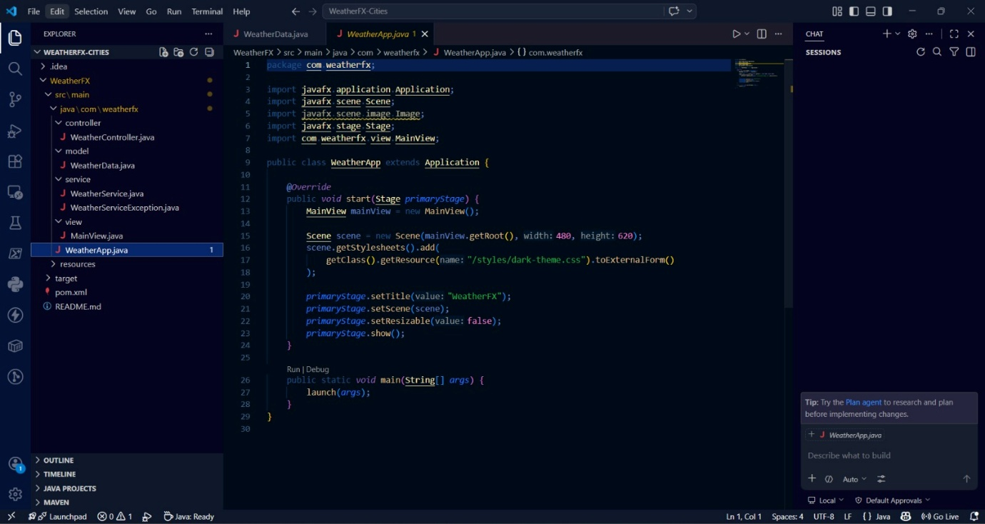
Figure 2: Weather Search Page
Explanation:
• Search bar for city input
• Weather display cards
• Responsive layout
• JavaScript for API calls

14. Weather Controller
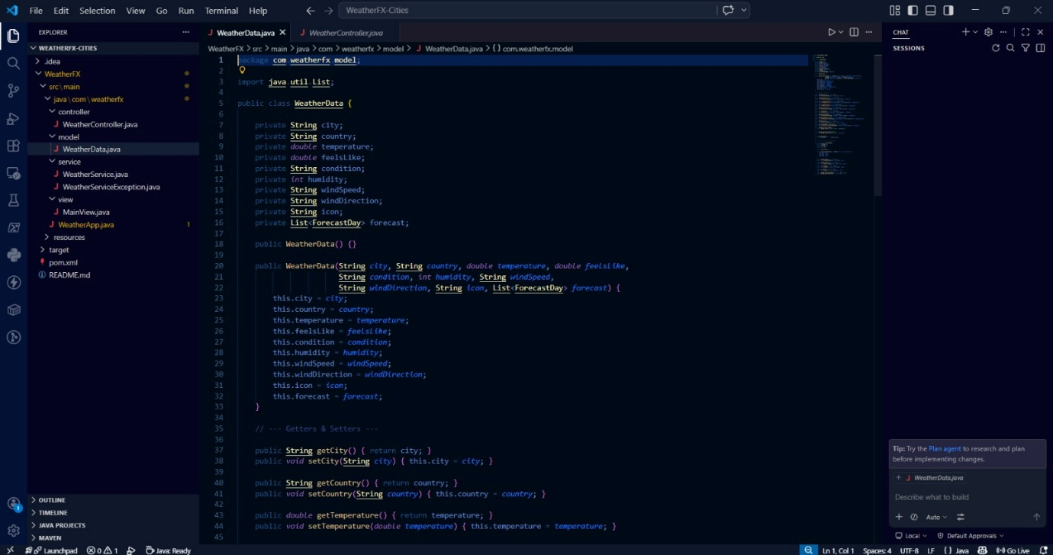
Figure 3: Weather Controller Implementation
Explanation:
• @RestController for REST API
• Endpoint: /weather
• Handles API requests
• Returns JSON response

15. Chatbot Controller
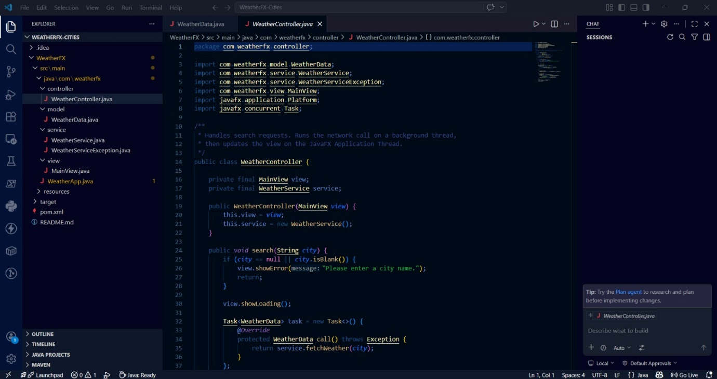
Figure 4: Chatbot Controller Implementation
Explanation:
• Endpoint: /api/chat
• Accepts user queries
• Returns chatbot responses

16. CODE AND RESULT
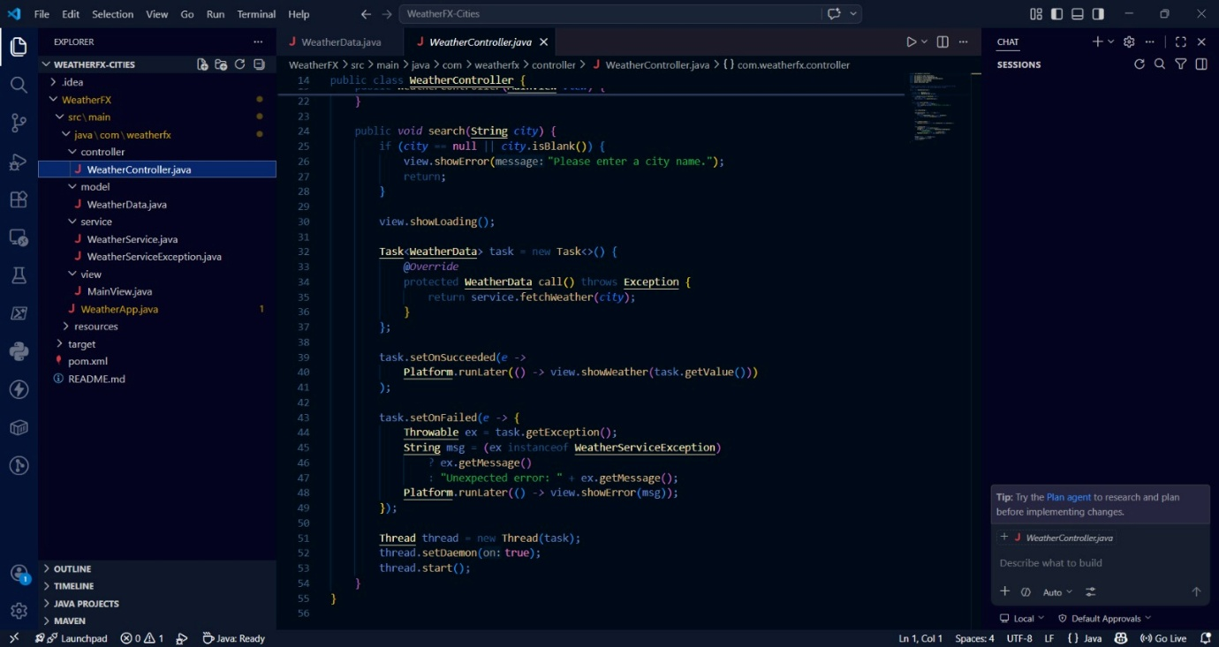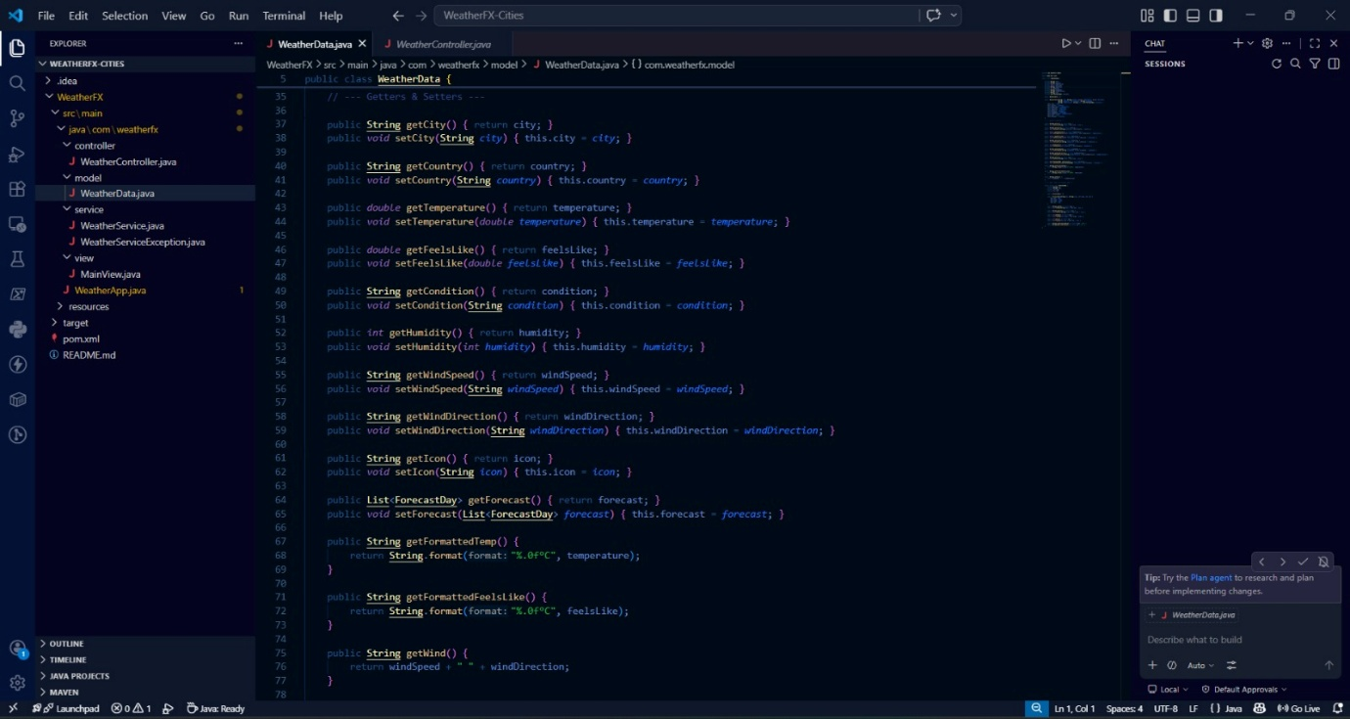
OUTPUT :
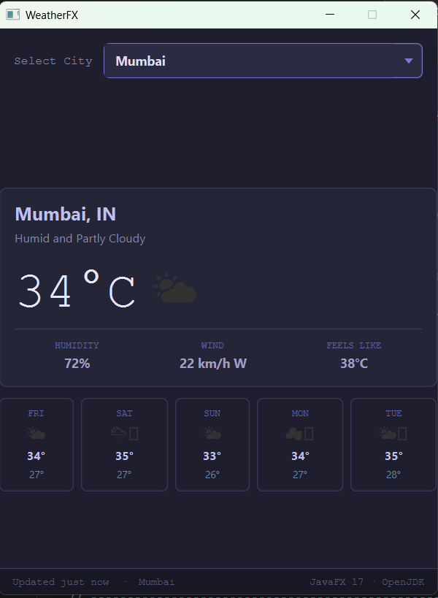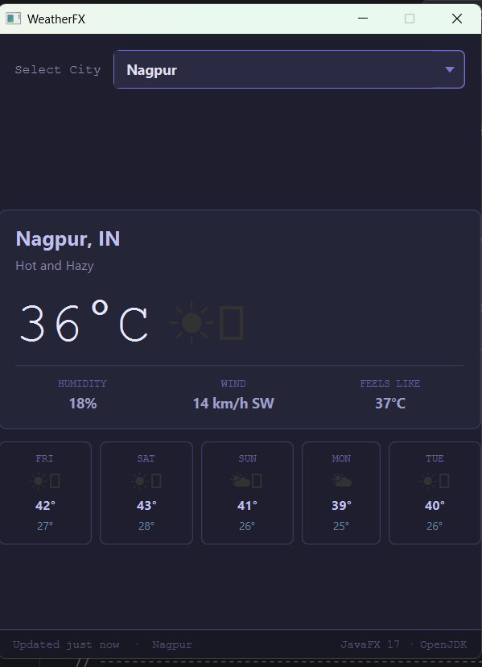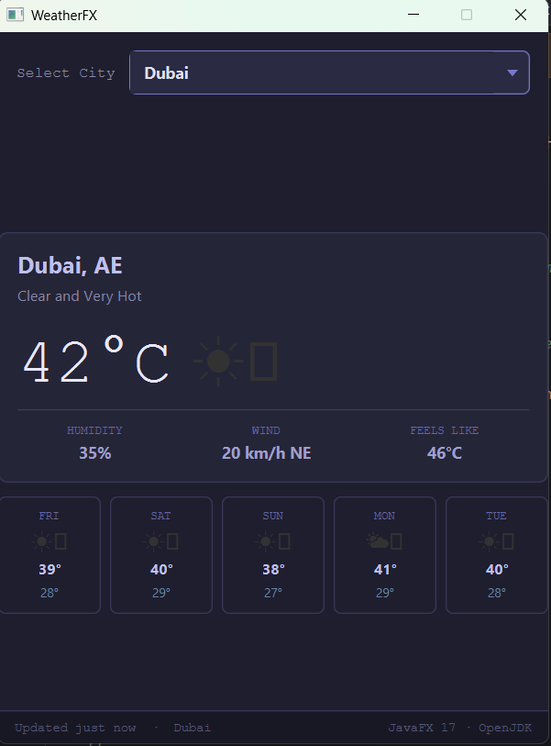

17. Conclusion
The Weather Report Application successfully demonstrates the integration of frontend and backend technologies to provide real-time weather information. The use of APIs ensures accurate data retrieval, while the chatbot enhances user interaction. This project serves as a scalable solution for future enhancements and deployment.

18. References
• Java Documentation
• Weather API Documentation
• HTML, CSS, JavaScript Tutorials
• REST API Concepts
• AI Chatbot Basics

19. Appendix (Optional)
• Screenshots of application
• Source code snippets
• UML diagrams

